🔬 HANDS-ON LAB: Windows Security Logs & Sysmon Telemetry
Goal:
Generate, observe, and understand real Windows + Sysmon events the way a SOC analyst does.

🧱 LAB SETUP (Minimum)
- Windows 10 or Windows 11 VM
- Sysmon installed
- Event Viewer access
- Local admin account

✅ PRE-LAB SETUP — WINDOWS LOGGING & SYSMON
(MANDATORY BEFORE ANY HANDS-ON LAB)

1️⃣ Confirm You’re Logging the RIGHT THINGS (Windows)

🔹 Check Security Auditing is Enabled
Open Local Security Policy:
secpol.msc
Go to:
Local Security Policy → Audit Policy
Make sure these are ENABLED:
Policy | Setting
Audit logon events | Success, Failure
Audit account logon events | Success, Failure
Audit process tracking | Success
Audit privilege use | Success
Audit policy change | Success
👉 If these are OFF → 4624, 4625, 4688 may NOT appear
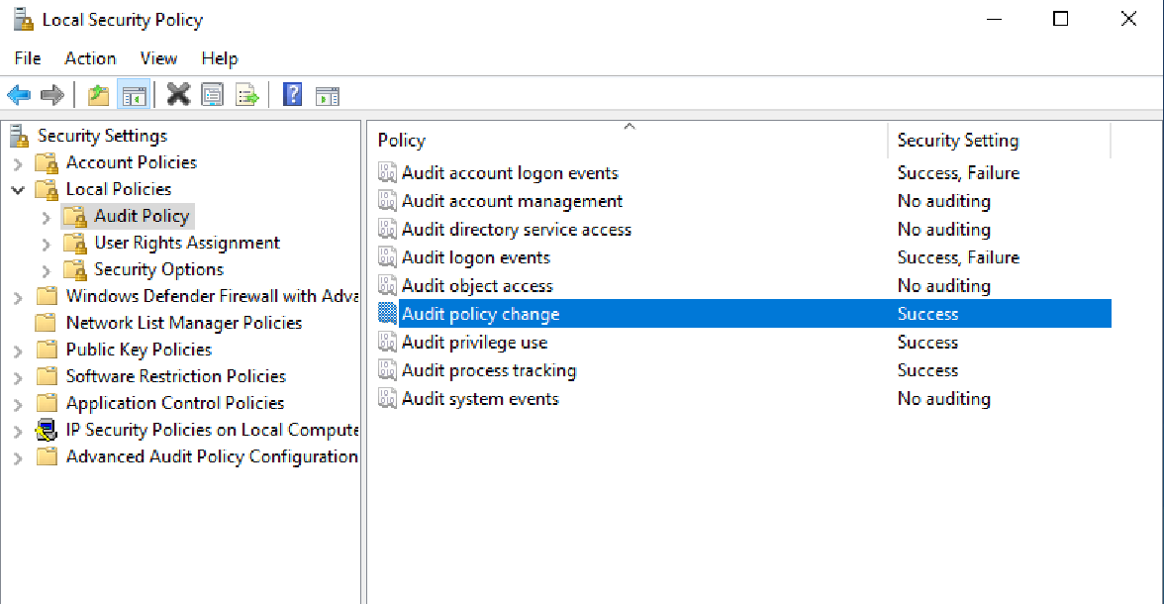

2️⃣ Verify Command-Line Logging for Processes (IMPORTANT)

🔹 Enable Process Command Line Logging
Open Group Policy Editor:
gpedit.msc
Navigate:
Computer Configuration
→ Administrative Templates
→ System
→ Audit Process Creation
Enable:
✔ Include command line in process creation events
Why this matters:
- Without this → Event ID 4688 is almost useless
- SOC needs command lines
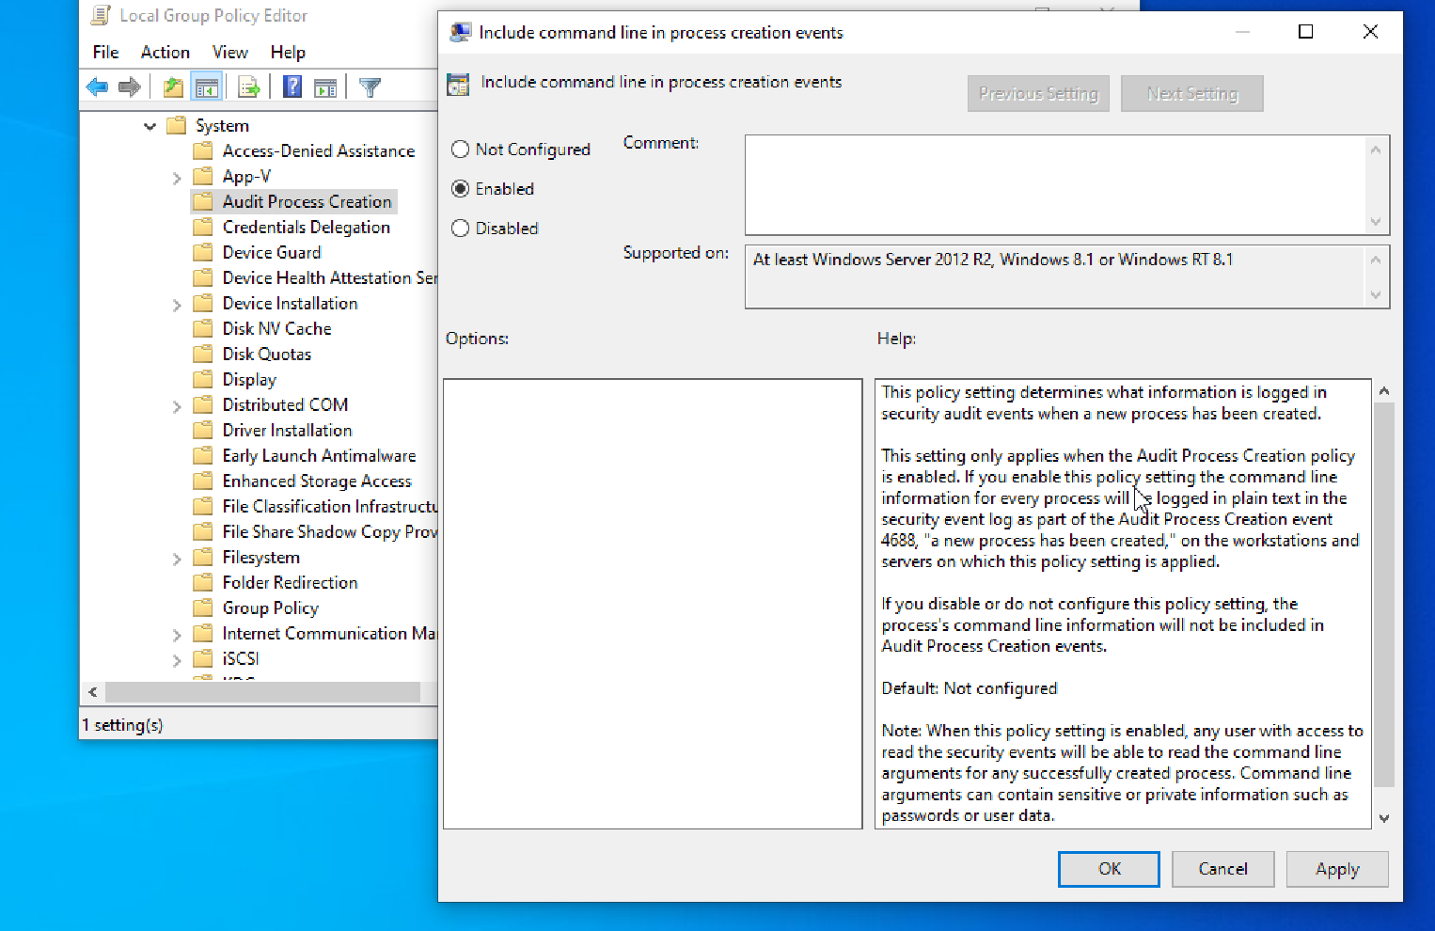

3️⃣ Confirm Windows Security Log is ACTUALLY POPULATING
Open:
Event Viewer → Windows Logs → Security
Check:
- New events are coming in
- Event IDs like 4624 appear when you log in/out
If Security log is empty → STOP
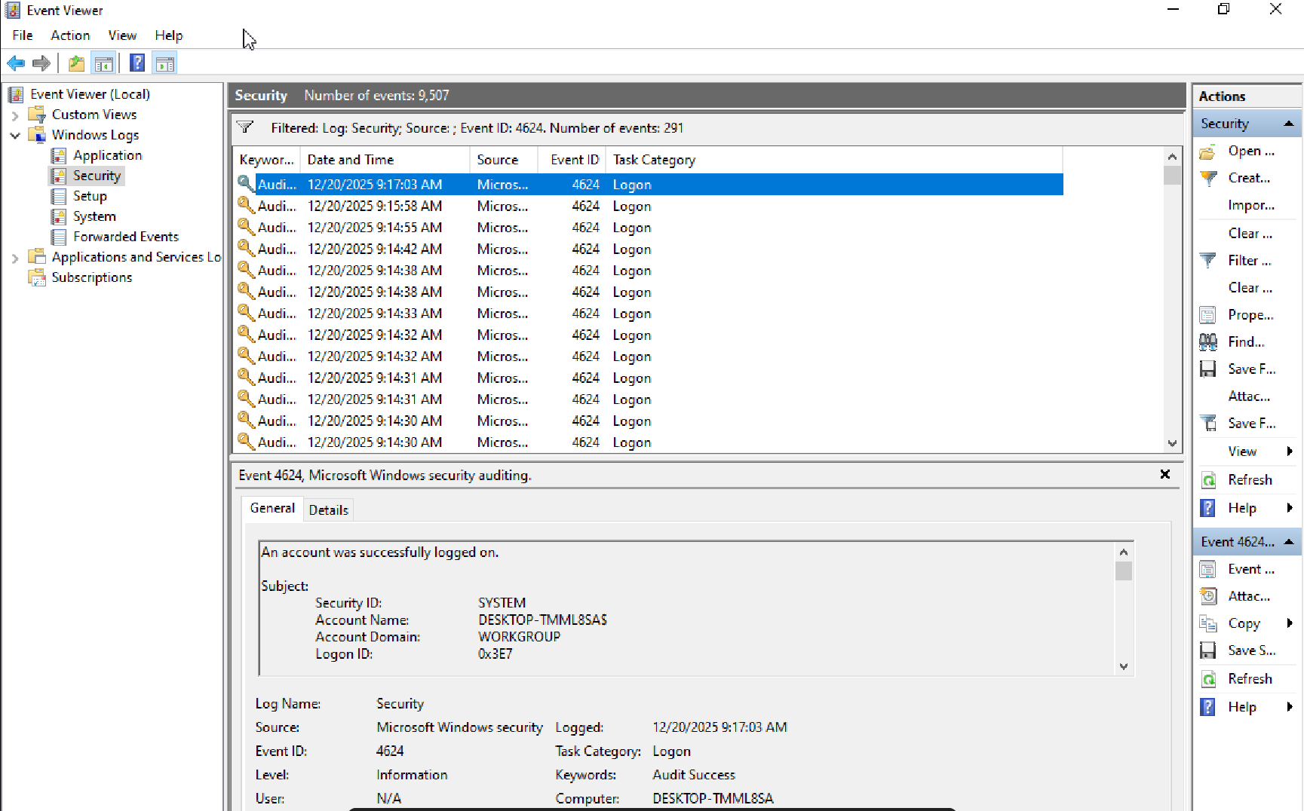

4️⃣ Check if Sysmon is Installed (DO NOT ASSUME)
Open Command Prompt (Admin):
sysmon -c

Possible outcomes:
- ✅ Config displayed → Sysmon is installed
- ❌ Command not found → Sysmon not installed
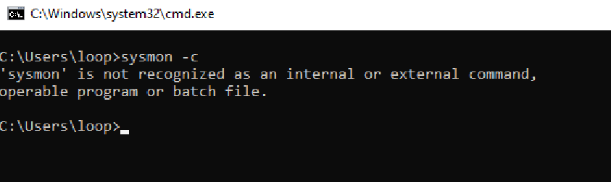
Alternative check:
Services → Sysmon
Service name:
Sysmon64
If Sysmon does not exist → install it (next step).

5️⃣ Install Sysmon (If Not Present)

🔹 Download Sysmon
From Microsoft Sysinternals.
Extract and run (Admin CMD):
sysmon64.exe -accepteula -i
⚠️ This installs Sysmon with default config (acceptable for beginner labs).
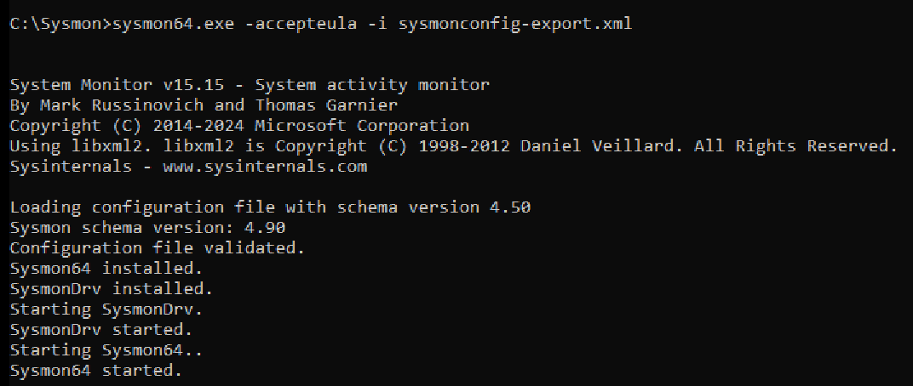

6️⃣ Confirm Sysmon is Generating Logs
Open:
Event Viewer
→ Applications and Services Logs
→ Microsoft
→ Windows
→ Sysmon
→ Operational
Check:
- Events are appearing
- Event ID 1 exists when you open apps
If empty → Sysmon is broken or misconfigured.
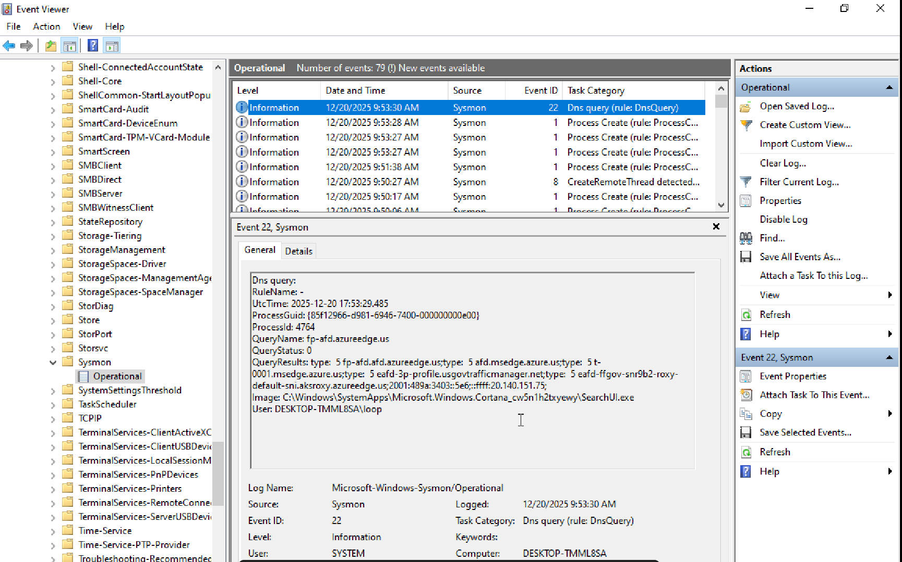

7️⃣ Verify Key Sysmon Event IDs Are Enabled
Run:
sysmon -c
Confirm logging includes:
- ProcessCreate (Event ID 1)
- NetworkConnect (Event ID 3)
- FileCreate (Event ID 11)
- RegistryEvent (Event ID 13)
- DnsQuery (Event ID 22)
If these are missing → detection labs will be incomplete.

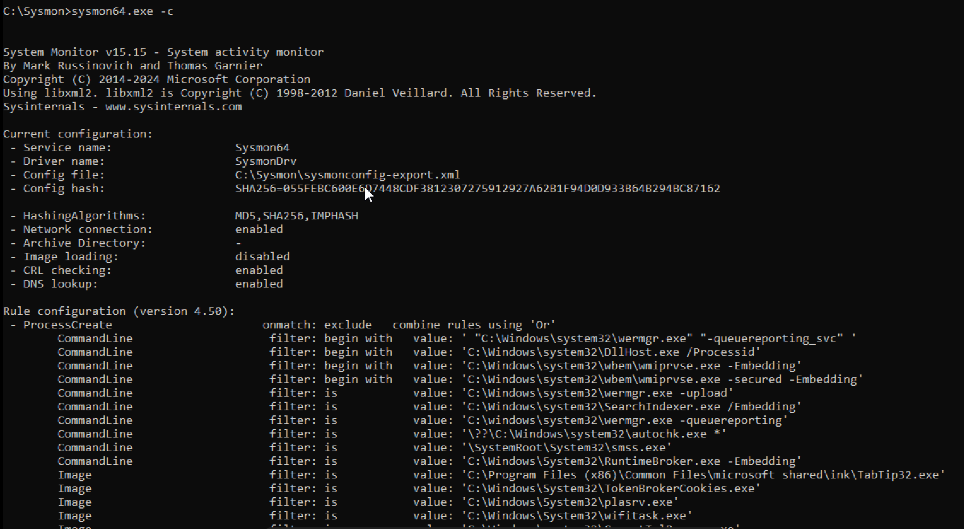

8️⃣ Time & Timezone Check (Often Ignored)
Open:
time /t
date /t
Ensure:
- Correct system time
- Correct timezone
SOC rule:
Bad time = broken timelines

9️⃣ User Account Context Check
Make sure you know:
- Which account is standard
- Which account is admin
Run:
whoami
SOC labs require you to know:
Was this action done as admin or user?

🔟 Final Pre-Lab Sanity Test (DO THIS)
Run these and verify logs appear:
notepad.exe
ping google.com
You should see:
- Security Event 4688
- Sysmon Event 1
- Sysmon Event 3
If you don’t → DO NOT PROCEED
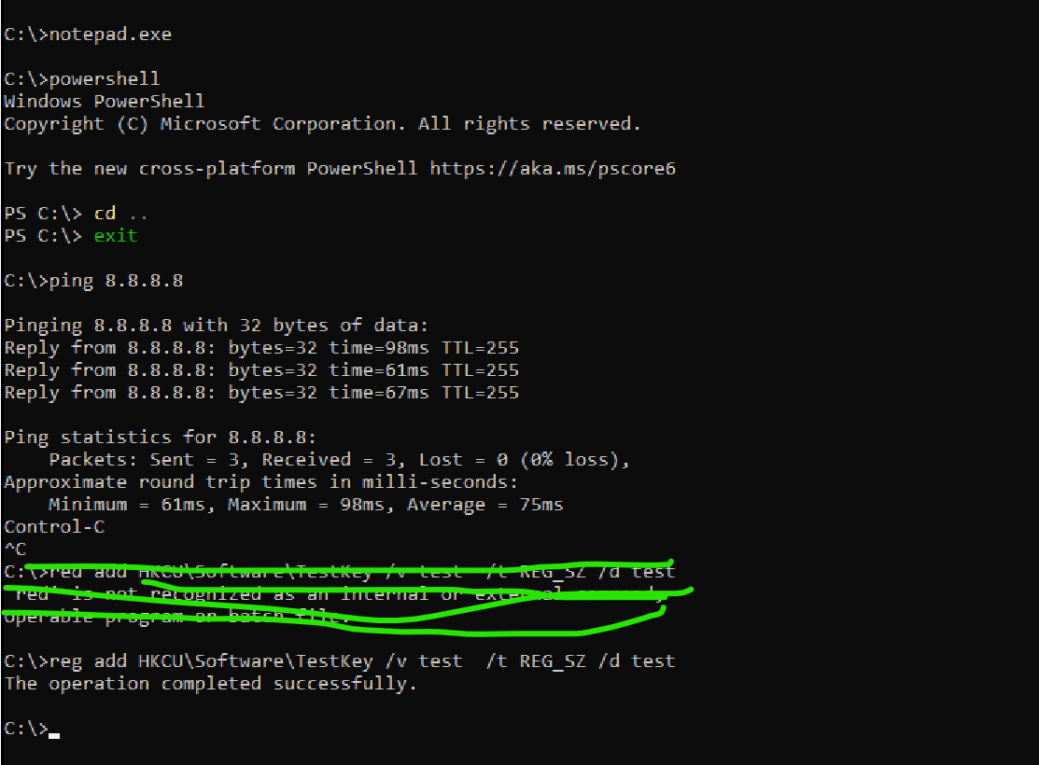
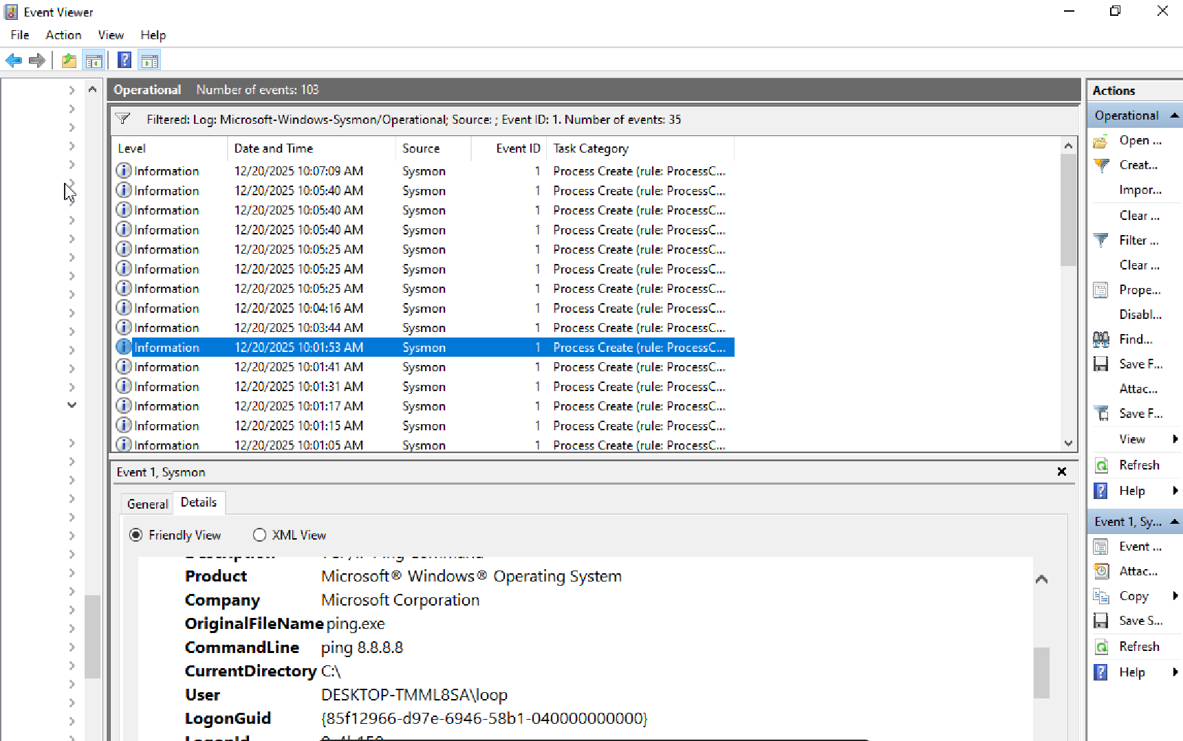

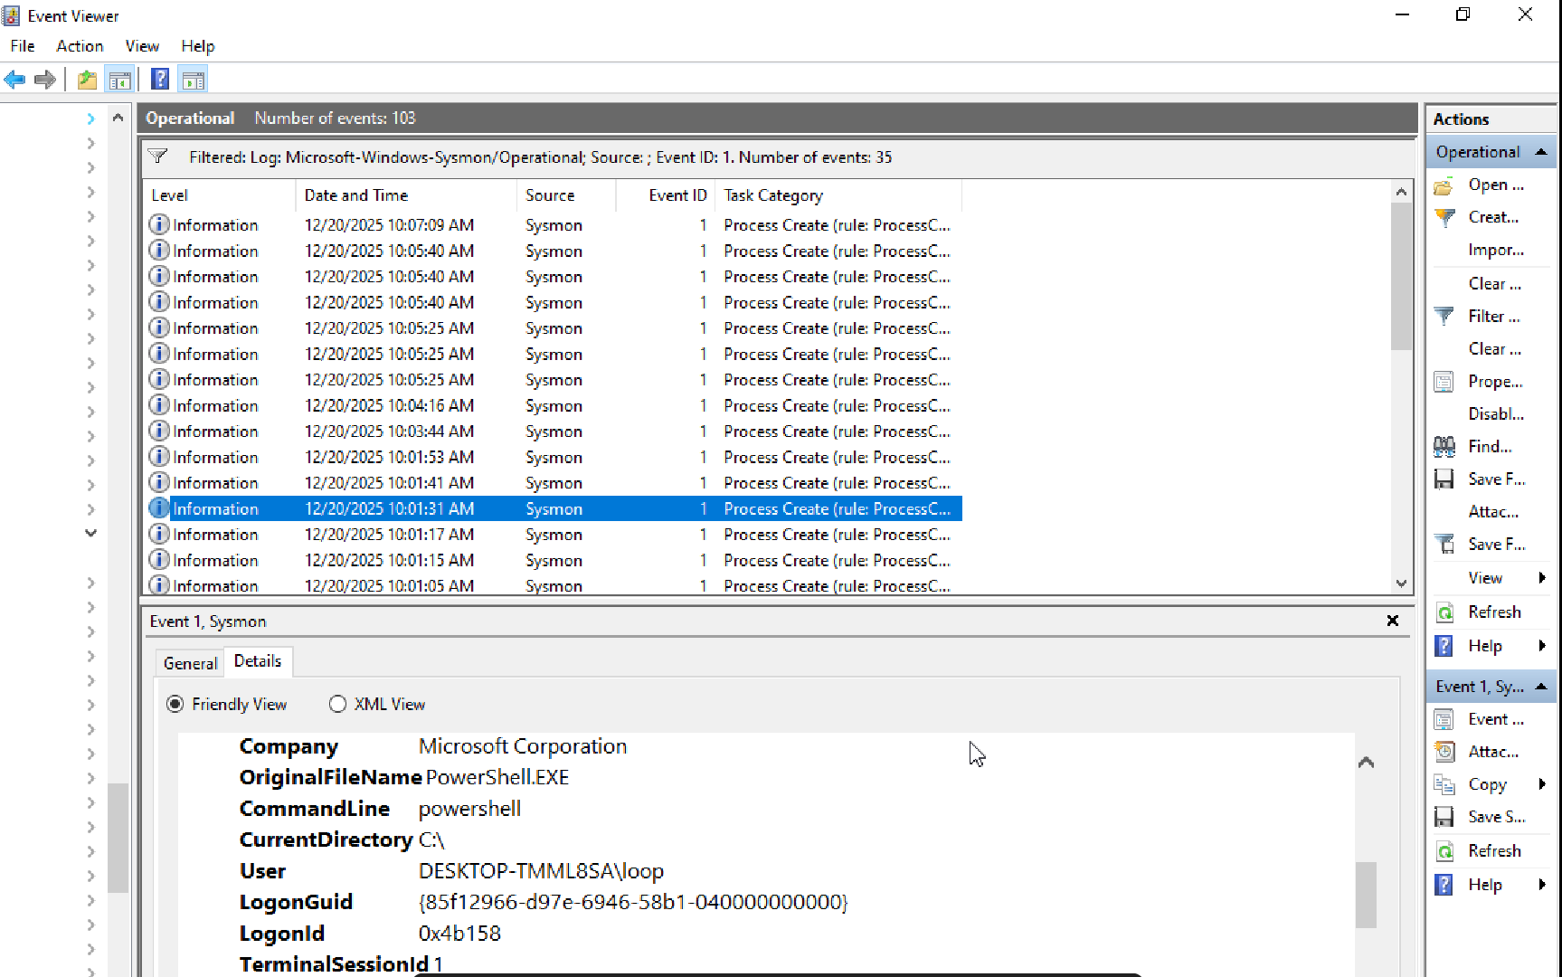

LAB 1️⃣ — Successful & Failed Logon (4624 / 4625)

🎯 Objective
Understand authentication telemetry.

Steps
- Log in to Windows with correct password
- Log out
- Log in again with wrong password (2–3 times)

Observe
Open:
Event Viewer → Windows Logs → Security
Filter by:
- 4624 (success)
- 4625 (failure)

What to check
- Account Name
- Logon Type
- Time
- Source
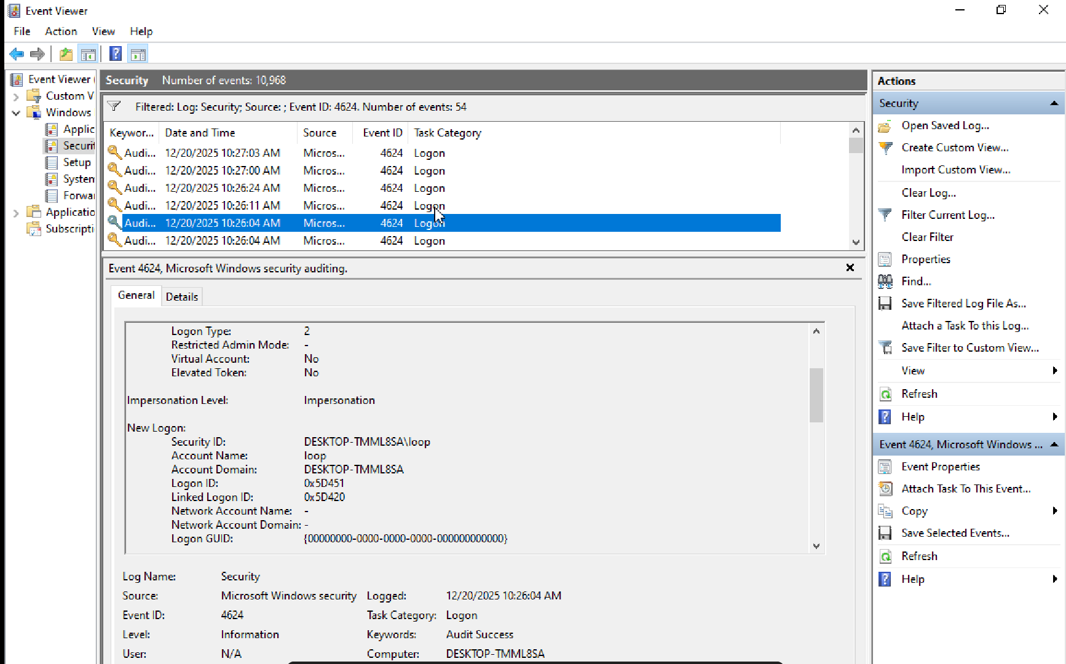

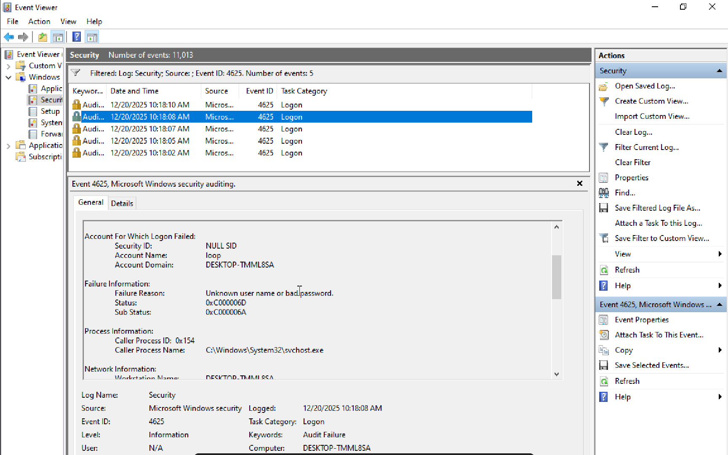

LAB 2️⃣ — Privileged Logon (4672)

🎯 Objective
See how admin access is logged.

Steps
- Log in using an Administrator account
- Open Command Prompt as admin

Observe
Filter Security log for:
- 4672

Key insight
Admin access is separate from telemetry, not just a normal login.
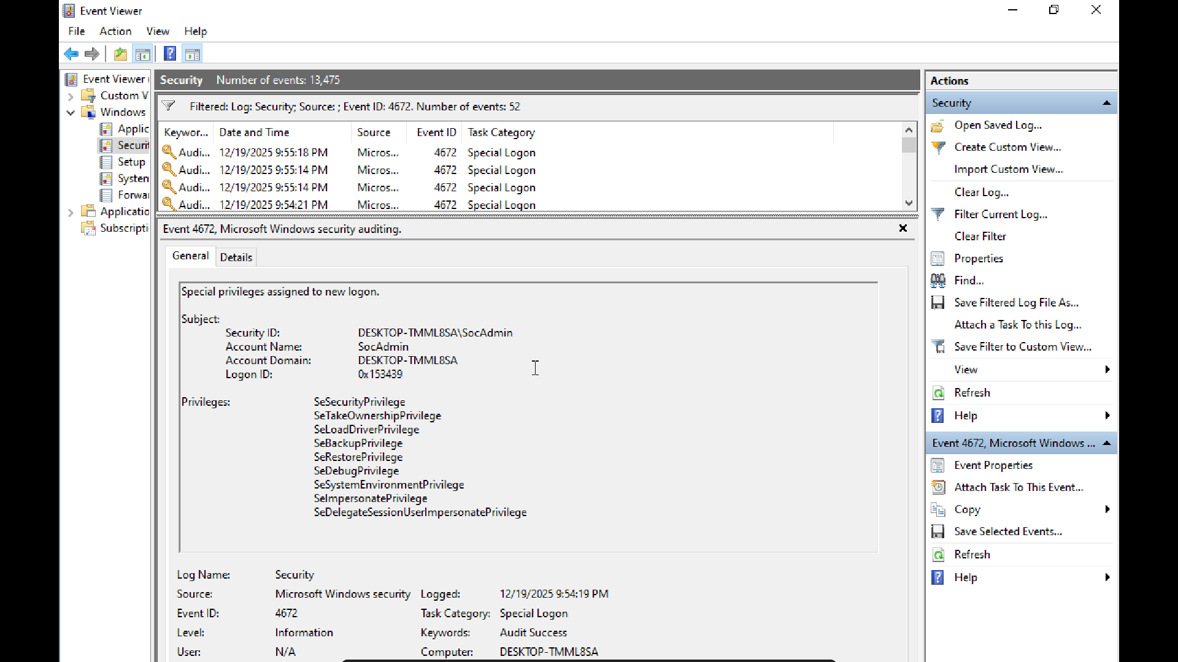

LAB 3️⃣ — Process Creation (4688)

🎯 Objective
Track process execution.

Steps
- Open Command Prompt
- Run:
cmd.exe

Observe
Filter Security log for:
- 4688

What to check
- New Process Name
- Parent Process
- 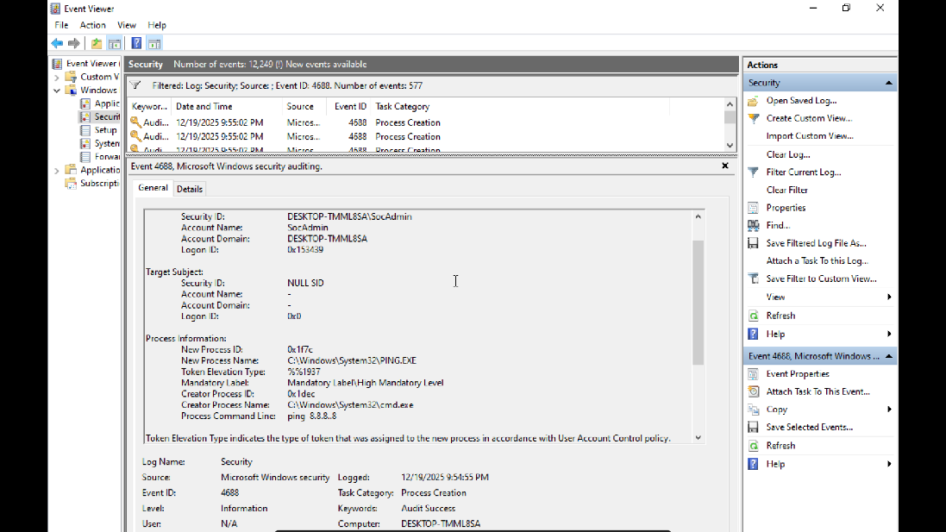

LAB 4️⃣ — Sysmon Process Creation (Event ID 1)

🎯 Objective
Compare Sysmon vs Security logs.

Steps
- Open:
powershell.exe
- Run:
whoami

Observe
Go to:
Applications and Services Logs
→ Microsoft
→ Windows
→ Sysmon
→ Operational
Filter:
- Event ID 1

Compare
- Command line visibility
- Parent image
- Hashes
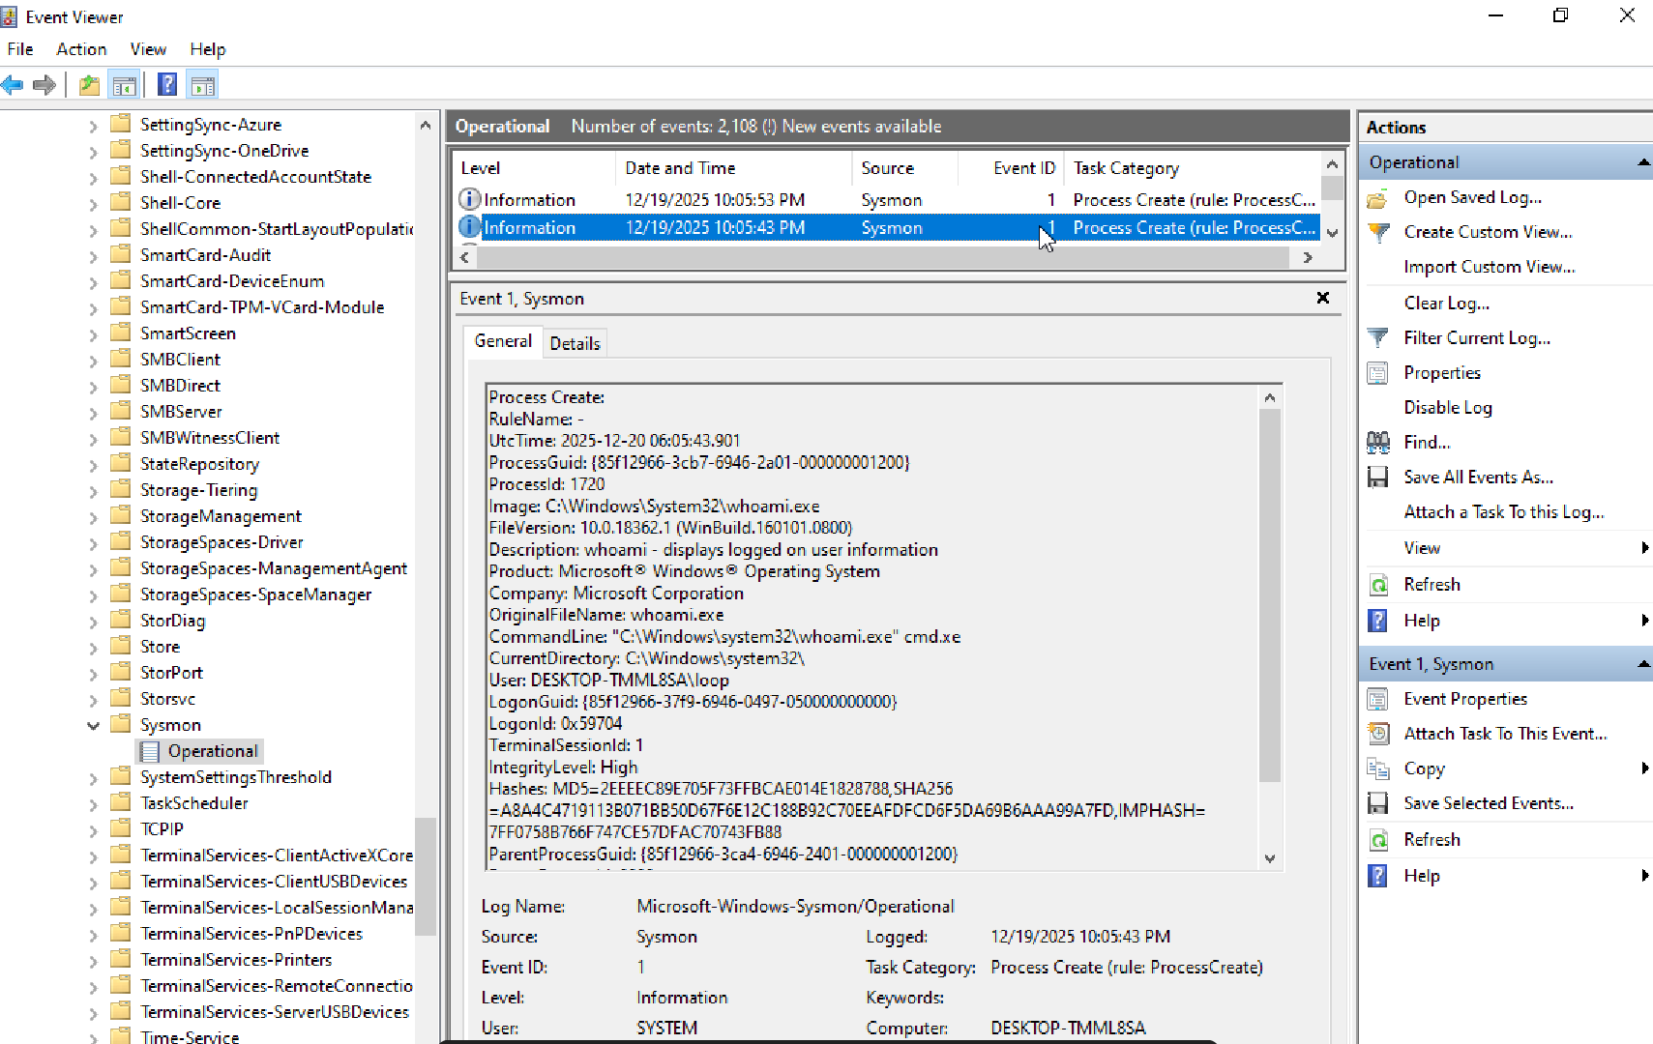

LAB 5️⃣ — Sysmon Network Connection (Event ID 3)

🎯 Objective
Link process → network.

Steps
In PowerShell:
ping google.com

Observe
Sysmon log:
- Event ID 3, dnsquery event id : 22

Key fields

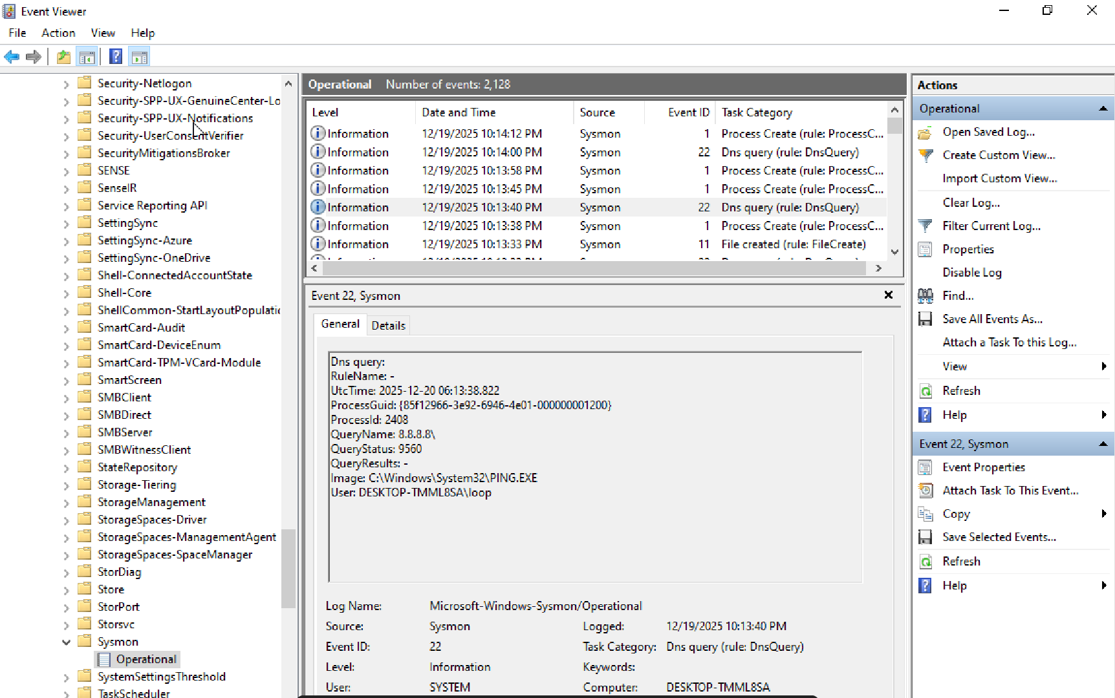

LAB 6️⃣ — File Creation (Sysmon Event ID 11)

🎯 Objective
See file write telemetry.

Steps
- Create a file:

echo test > C:\Users\Public\testfile.ps1

Observe
Sysmon:
- Event ID 11

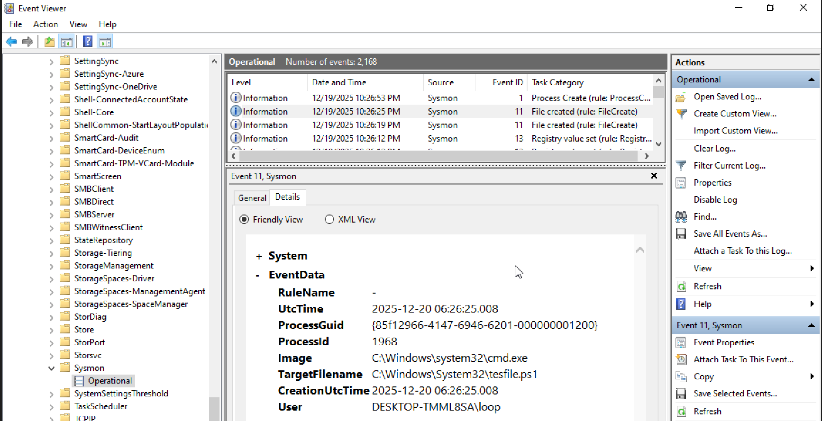

✅ Conclusion
This hands-on lab successfully demonstrated how Windows Security logs and Sysmon telemetry work together to provide visibility into user activity, privilege usage, process execution, network connections, and file creation — exactly as observed in real SOC environments.
Through structured pre-lab validation, we confirmed that proper auditing and Sysmon configuration are mandatory before any detection work can be trusted. Missing audit policies or misconfigured Sysmon rules result in blind spots that can falsely appear as “no activity.”
Key takeaways from the labs:
- Authentication events (4624 / 4625) reliably show successful and failed logons, including logon type and source.
- Privileged access is not represented by a single event. While Event ID 4672 may indicate special privileges, it is not guaranteed for interactive admin users on modern Windows due to UAC behavior.
- Elevated process creation (4688 with TokenElevationType = %%1937) is the most reliable indicator of admin activity.
- Sysmon provides deeper behavioral visibility than native Security logs, including:
  - Process lineage and hashes (Event ID 1)
  - Process-to-network relationships (Event ID 3, 22)
  - Risk-based file creation telemetry (Event ID 11)
- Sysmon intentionally filters noise, logging only higher-risk file writes and actions, which aligns with real SOC detection strategies.
Overall, this lab reinforces a critical SOC principle:
Security visibility comes from correlating multiple events across Windows and Sysmon logs — never from relying on a single Event ID.
The exercises mirror real-world SOC workflows and build a solid foundation for detection engineering, alert triage, and incident investigation.

